Sample Problem : Export Subsidy

Q1.

Tradia is a small export country. Suppose initially that the world price is $150. Due to successful lobbying activities, Tradia producers will now receive a subsidy of $25 per unit exported. Use the following figure to answer the following questions.

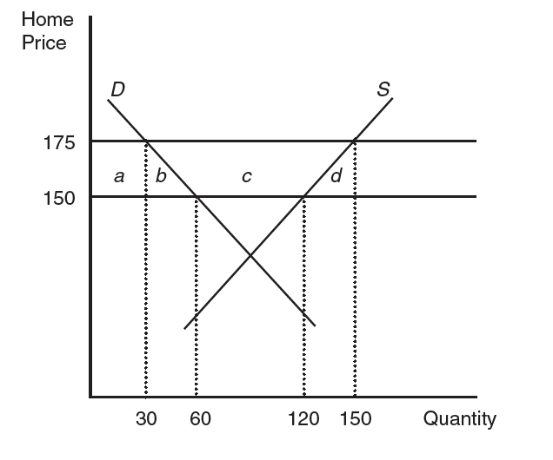

a. Do you expect Tradia to export more with the subsidy? If so, by how much?

b. What is the change in consumer surplus due to the subsidy?

Loss in consumer surplus:

c. What is the gain/loss in producer surplus with the subsidy?

Gain in producer surplus:

d. How does the subsidy affect welfare in Tradia?

Loss in consumer surplus:

Rise in producer surplus:

Revenue cost of subsidy:

The net effect on welfare:

Q2.

Islandia is a small exporting country with supply and demand given by the following equations:

D =100 - 5P

S =10P + 50

Suppose the free-trade world price is $12 per unit.

price S

20

15

12

10

D

25 40 50 70 100 q

1. In the absence to any barriers to trade, what is the domestic consumption and production? How much is exported?
2. Suppose the Islandia government offers the island producers an export subsidy of $3 per unit. Calculate the price paid and quantity demanded by island consumers.
3. Calculate the net effect of the export subsidy on Islandia welfare.

Q3.

Suppose the supply and demand for Continentia, a large country, is as follows:

D = 900,000 - 150P

S = 100,000 - 50P

Assume that the free-trade world price is $5,000 per unit. Further assume that the Continentia government offers an export subsidy that increases the domestic market price to $5,500 and lowers the world price to $4,500. However, starting next month, the Continentia government will be removing the export subsidy in compliance with the latest international trade pact.

1. What is the impact of the removal of the subsidy on domestic consumers?

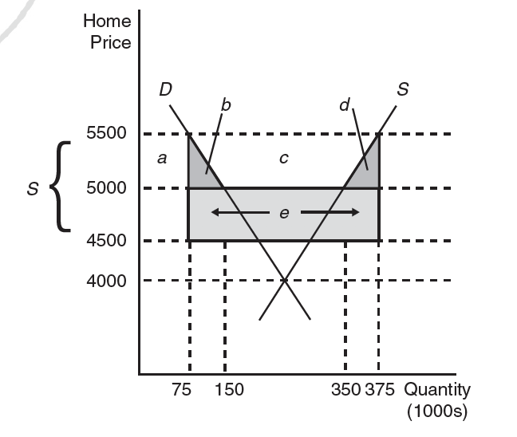

1. What is the change in producer surplus due to the movement to free trade?
2. What is the net effect of moving to free trade on Continentia welfare?
3. Would Continentia consumers support or oppose the policy for free trade? What about producers?